CARBURETOR POWER SYSTEM - Non-electronic carburetors use a Power valve to enrich the mixture during acceleration or high speed operation (to prevent detonation). This system is modified for Turbo applications. (One reason a Turbo carb is different than other carbs.) The power system works off manifold vacuum. Low or no-vacuum situations open the release (open) the power valve. Most carbs get this vacuum signal from a port with the carb. In a draw-through turbo set up, the carburetor is separated from the intake by the turbocharger. Releasing the throttle when the engine is under boost will produce vacuum within the plenum. However the intake will still be supercharged. The plenum vacuum will close the power valve and lean out the mixture and cause detonation. To correct this, the power system needs to be connected to the intake manifold down stream of the turbo. It also needs to be protected from boost pressure. (When the intake is pressurized, the power valve should receive no vacuum and no pressure). This is accomplished with a Power Enrichment Control Valve (PECV) or Turbocharger Vacuum Bleed Valve (TVBV).

PECV [Power Enrichment Control Valve] GM Part # 25500683
This is one of those parts that is unobtainium.
This valve is used to control the Power Piston in the carburetor, to increase the fuel delivery during boost conditions, and prevent boost pressure from reaching the power valve. It is screwed into the top/front of the manifold where it senses the vac./boost pressure . There are three other vac. lines connected to it. The center port is connected to the carburetor power piston and controls the richness of the mixture. The other two ports are connected to the carburetor vac. source and the vent of the carburetor.
Below the valve threshold, the carburetor power piston is connected to the carburetor vac. source and is controlled according to the engine load. As the pressure increases to a point above the valve threshold the carburetor power piston is connected to the carburetor vent. This allows the power piston spring to lift the power piston fully and the carburetor goes to full rich.
When the diaphragm in this valve fails, the carburetor power piston will most probably see positive pressure under boost, leading to a lean condition. There are then two choices; connect the carburetor for a full rich or full lean condition. Neither of these choices is good. Under full rich conditions the fuel consumption will be atrocious, and excess fuel will wash the oil film from cylinder walls causing premature wear. The full lean condition will cause detonation on boost. Either of these conditions can result in severe engine damage.
PECV ALTERNATIVE
This is the simplest option I have found and will give better results than the full lean or full rich conditions. It only requires obtaining one part from your local parts store or wrecking yard, and a simple bit of wiring. The part required is a three port vacuum switch. I obtained mine at the wrecking yard from some unidentified Japanese car. Any three port switch will work.
To get power to energize the switch, connect it to the yellow boost indicator light. I found on my car that the yellow light comes on at zero boost, and the red light comes on at about 5 P.S.I.. On the firewall there are two vacuum switches which operate the boost indicator lights; one for the red and one for the yellow light. Check the switch that operates the yellow light for the ungrounded side. This is where one side of the three port vacuum switch should be connected. The other side of three port vac. switch should be connected to a 12 volt switched source. With this wiring the switch will change the power valve from vacuum control, to full rich, at zero P.S.I..
The original PECV should be removed from the manifold and the hole plugged. Three vacuum connections are required. The common port of the vac. switch should be connected to the power valve port on the carburetor. The normally open port should be connected to the manifold vac./boost port, and the normally closed port to the carburetor vent port. It will be necessary to use some "T" connections to accomplish this, as you do not want to disconnect any other original vacuum connections.
INSTALLATION
The installation is simple and only requires finding a place to mount the three port vac.switch, and then piping it into the system as shown. The switch should be mounted as close to the boost switches as possible to avoid long vac. lines. Only two wires are required, one from the boost light to the vac. switch and one from the vac. switch to a 12 volt switched source, as shown in the wiring diagram. Under the dash there is convenient grommet where the wires can be passed through from the cockpit to the engine compartment. The grommet is located just above and to the right of the steering column.
If the vac. switch ports are not identified, mine were not, they can be identified in the following manner: Blow through the ports. The two that you can blow through are the common and normally open. Now energize the switch and blow through again. The ports you are now blowing through will be the common and the normally closed. The common port will be that which you can blow through under both conditions.
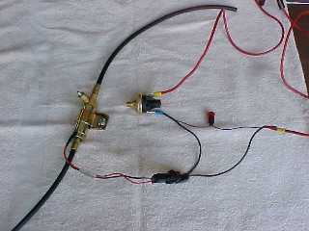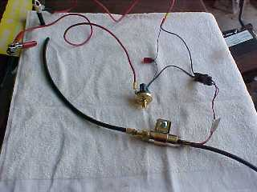
Here is the three port vacuum switch wired to a Hobbs pressure switch

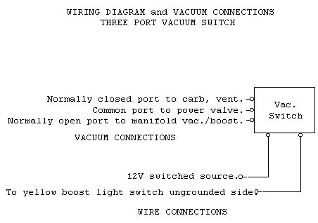
TEST AND ADJUSTMENT
To test the function just drive the car and listen for a click as the yellow light comes on. This is the vac.switch switching, at which point the carb. goes to full rich. There are no adjustments to be made because the whole process is controlled by the boost light switch.
ESC {Electronic Spark Control} and PECV COMBINATION
The ESC was a device used by Buick to control the spark advance and retard. I have had no luck in obtaining a schematic for this device so I do not know it's exact function. However, from my own experience, the Buick manual and other references I believe it to work something like this. A Knock Sensor [a piezo electric device which develops a voltage under pressure] is screwed into the manifold and detects the vibrations of detonation. This signal is processed by the ESC [turbo control center] and results in the ignition timing being retarded until the detonation stops. This retard can be as much as 20 degrees depending on the severity of the knock. As you can see from this brief description this is a post problem device. In other words the retard sequence is not initiated until the detonation has occurred. This is OK as a safety device to stop detonation under adverse conditions, but from my experience this device is controlling the ignition under all boost conditions.
When detonation has already occurred, it takes more ignition retard to quench it than it would have taken to prevent it in the first place. As an example, if the engine starts to detonate at say 5 P.S.I. it may take as much as 5 or 6 degrees of retard to quench the detonation. However if the ignition was retarded initially 2 or 3 degrees at this point the detonation would not have initiated. Of course this is all a delicate balancing act, and I am not sure exactly how this was managed in the Buick device. If anyone can give me more details of this device it would be more than welcome.
I was experiencing lots of detonation problems at WOT [wide open throttle], and assumed, after lots of tests, that it was the ESC to blame. I was later to find that the ESC was indeed functioning. However having already designed the device, I am about to describe, I built it and installed it anyway. The performance of the car was vastly improved. The detonation stopped and the acceleration improved. All of this is by "the seat of the pants method" and I can not back this with numbers. Yet!
OPTIONS
There are three basic options available commercially to retard the ignition. The first is a unit which will give a fixed amount of retard over the full range of the distributor settings. The MSD unit used in this project is an example of these. Using this is like advancing or retarding the distributor, except of course it can be done from the drivers seat.
Then there is the type that retard based on boost pressure. These will generally give a fixed amount of retard for each increase in boost of one P.S.I. For example, dial in one degree of retard and you get one degree at one P.S.I. and ten degrees at ten P.S.I.
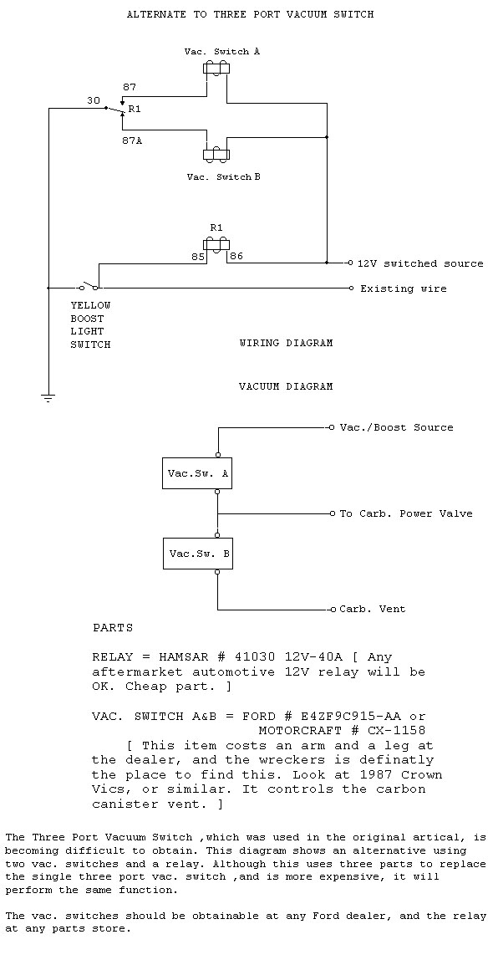
On your web site in looking at the diagram of the vacuum lines; I see that the PEVR has a line to the carburetor and the other line goes where?
The power valve in the carb is normal plumbed internally to vacuum. On a draw-thru boosted motor, it needs to be referenced to post turbo vacuum/pressure (when the intake is under pressure and the PV should be open, the carb before the turbo sees vacuum, which holds the power valve closed causing a lean condition). There is a line coming from and another returning to the carb (plus a bunch of side paths T'd into it
The vacuum line to the power valve is plumbed externally on a Turbo V6 carb, but the vacuum source is still from within the carb. In this line is the PEVR which blocks the signal when the intake is under boost.
Instead of taking the vacuum signal from the bottom of the carb, you could get it from the intake manifold. An in-line check valve will stop boost from reaching the power valve. This is recommended in books I've read; I believe this is how Fred did it with the Holley carb he ran.
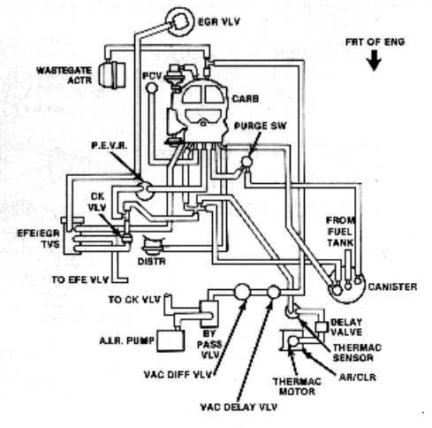
I believe you would disconnect the PEVR at the T below it and cap off the T. Then you remove the PEVR and replace it with a barbed hose fitting. Connect the line that went to the PEVR here and splice in the check valve.
I think I read about this in Turbochargers by Hugh MacInnes.

 | Pressure Switch Standard Specifications  Type: Direct action blade contact  Contacts: Silver alloy, gold plated  Set Point: Factory set from 0.5 to 150 PSI  Operating Pressure: 150 PSI for 0.5-24 PSI set point range, 250 PSI for 25-150 PSI set point range  Proof Pressure: 500 PSI  Burst Pressure: 750 PSI for 0.5-24 PSI set point range 1250 PSI for 25-150 PSI set point range.  Ratings:  Resistive: 15 AMP-6 VDC 8 AMP-12 VDC 4 AMP-24 VDC  Inductive: 1 AMP-120 VAC 0.5 AMP-240 VAC  Diaphragm: Polyimide film  Temperature Range: -40° F to + 250° F  Connector: 1/8 -27 NPT male thread  Terminals: #8-32 screws, 1/4" blade, 280 Series Metri-Pack  Circuitry: -SPST-N.O., N.C., 1 circuit adjustable dual circuit, or 2 circuits adjustable dual circuit. Also available are N.O./N.O. dual circuit and N.C./N.C. dual circuit.  Base: Plated Steel  Cover: Glass reinforced polyester  Options: Brass, plastic or stainless steel base; various base connector thread sizes; wire leads (potted & sealed). | 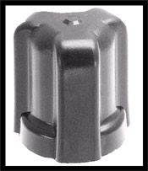  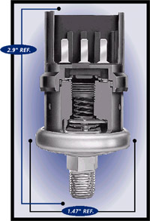  back to top
  The 5000 Series switch is specifically designed to stand up to extended duty applications. This switch is factory set but capable of field adjustment. It features a Kapton diaphragm for compatibility with a wide variety of fluids, and various terminations including a Metri-Pack connector that forms a tight seal when connected. Among the outstanding design benefits are its durable construction, compact size, and enhanced set point integrity.
  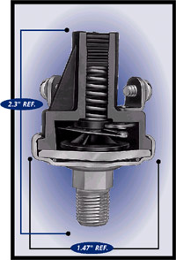
  5000 Series Switch
  with Screw Terminals
  Switch Boot P/N 79380
  for Vacuum and Pressure
  5000 Series Switch
  with Metri-Pack Terminals

  NOTE: OPERATING MEDIA (PRESSURE SWITCH) The pressure switch is designed to operate with air, motor oils, transmission oils, jet fuels and other similar hydrocarbon media.
  WARNING! Suitability of application is responsibility of user. Extreme heat and vibration should be avoided at mounting points such as on top of an engine over a hot manifold. (MAX operation temp 250° F). Always install by using a wrench on the hex base. Torquing at any other part of the switch voids the warranty or may cause malfunction. A Polyimide film diaphragm is utilized in the pressure switch and is not recommended for use with water. However, a Teflon diaphragm is available for water applications. Compatibility with the brass or steel external pressure switch material is the responsibility of the user. Max operating pressure (PSI) - 250 Max for 25-150 PSI set point 150 Max for 0.5-24 PSI set point Contact Hobbs Engineering whenever use of switch or fluid compatibility is questioned.

5000 Series Pressure Switch With Standard Terminal
 |  |  | Single Circuit 1 Terminal |  | Single Circuit 2Terminals |  | Dual Circuit One circuit adjustable¹ |  | Dual Circuit Boths circuits adjustable²
Contact Setting | Factory Set At | Circuitry | Part Number |  | Part Number |  | Part Number |  | Contact Setting 3 | Part Number
Contact Setting | Factory Set At | Circuitry | Screw | Blade | Screw | Blade | Screw | Blade | Contact Setting 3 | Screw | Blade
0.5-1 PSI ±0.3 | 1 PSI | N.O. | 78630 | 78631 | 78628 | 78629 | 78711 | 78712 | 3-4 PSI ±0.5 | 76081 | 76086
0.5-1 PSI ±0.3 | 1 PSI | N.C. | 78634 | 78635 | 78632 | 78633
1.1-3 PSI ±0.5 | 2 PSI | N.O. | 78142 | 78399 | 76051 | 76056 | 76071 | 76076 | 5-8 PSI ±1 | 76582 | 76590
1.1-3 PSI ±0.5 | 2 PSI | N.C. | 78149 | 78406 | 76061 | 76066
3.1-7 PSI ±1 | 4 PSI | N.O. | 78143 | 78400 | 76575 | 76583 | 76579 | 76587 | 9-24 PSI ±2 | 76082 | 76087

Switch P/N 76575-4 PSI is normally open and would close the contacts @ 4 PSI. This would then send current to the solenoid to shut off the vacuum.

You can purchase this by going to WWW.Stewartwarner.com to find your nearest dealer or purchase from NAPA as their P/N 701-1575.

Best Regards,

Tom Turnbull
Global Product Manager
Ph 217-753-7791
Fax 217-753-7789
email: Tom.Turnbull@honeywell.com

