ELECTRONIC SPARK CONTROL (ESC) - The Achilles' heel to a turbo set up is detonation, or knocking. Under boost, detonation increases and will damage the engine. The ESC system was first used in 1978 and is what made the turbocharger practical for Buick's V6 application. Most earlier and aftermarket systems use water injection to reduce detonation. Buick engineers developed the ESC system. The system uses a sensor to "listen" for knocking. When knocking is detected, the ESC retards the engine's timing to prevent it. The more knocking, the more retarding of timing, the less performance. To avoid knocking (and therefore maximize performance) use premium high-octane fuel. The higher the octane, the greater the fuels resistance to detonation.
Buick engineers developed the ESC system for the TurboV6 in 1978 and it was added to the 4.1 V6 in 1981. The 1978-'79 knock sensor is located on the intake manifold and it moved to the rear of the engine block in 1980. The "TURBO CONTROL CENTER" on the fan shroud of 1978 and '79 models is the ESC.
ESC KNOCK SENSOR - All Turbo V6 motors use a knock, or detonation, sensor. The sensor located on the rear of the block is almost impossible to even see. For TurboV6 engines, it may be necessary to remove the Turbo/Plenum assembly to change them. When installing, refer to the appropriate Service Manual for torque specifications. Improperly tightened sensors may not operate correctly. All 1978-'82 turbo and '81-'82 4.1 engines use an accelerometer, GM part number 1997463. In 1983, the sensor was changed to a piezo element, GM number 1997562. This sensor was used on many GM engines long after 1983 and is stamped DR-562. The piezo element "generates a better signal" (according to Buick) and is much cheaper. I believe the sensors have different resistance values, so interchange is not possible unless the controller is changed or modified.

Turbo and 4.1 ESC Systems
Note: While I have proof read the numbers, please confirm them before making decisions regarding your car. Also, the books are NOT always 100% correct!
Year | Model | Engine | Controller | Location | Sensor | Location
1978 | All | 231G,3 | 16005964 | Fan Shroud | 1997463 | Intake Manifold
1979 | A,B | 231-3 | 16005964 | Fan Shroud | 1997463 | Intake Manifold
 | E | 231-3 | 16006614 | Fan Shroud | 1997463 | Intake Manifold
1980 | A,B,E | 231-3 (no ECM, Fed) | 16011825 | Under Dash*** | 1997463 | Top, Rear of Block
 | A,B,E | 231-3 (ECM, CA) | 16011822 | Under Dash | 1997463 | Top, Rear of Block
1981 | A,E | 231-3 (ECM) | 1224743 | Under Dash | 1997463 | Top, Rear of Block
 | A,E | 231-3 (no ECM, Export) | 16011825 | Under Dash | 1997463 | Top, Rear of Block
 | B,C | 4.1-4 | 1224745 | Under Dash | 1997463 | Top, Rear of Block
1982* | G | 231-3 (1st Des) | 16014064 | Under Dash | 1997463 | Top, Rear of Block
 | E | 231-3 (1st Des) | 16019684 | Under Dash? | 1997463 | Top, Rear of Block
 | G,B,C,E | 4.1 (1st Des) | 16019684 | Under Dash? | 1997463 | Top, Rear of Block
 | G,B,C,E | 231-3, 4.1 (2nd Des) | 16017464 | Under Dash? | 1997463 | Top, Rear of Block
1983** | G,E | 231-8 | 16022614 | Right Inner Fender | 10456287 | Top, Rear of Block
 | G,B,C,E | 4.1 | 16022624 | Right Inner Fender? | 10456287 | Top, Rear of Block
Controller: Group 2.383 (Some Controller Part Numbers are for remanufactured GM parts.)
Sensor: Group 3.682
*It may be possible to swap 1982 1st and 2nd Design controllers by also swapping the short wiring harness connected to them. 1982 1st and 2nd Design controllers can be identified by the part number located on the part itself.
** 1983 controllers and sensors were used in later years and on various engines. Check Parts Book
***On the '82 Regal the controller is found by removing the lower panel from under the steering column and looking up towards the center of the Dash board. On the '82 LeSabre, the controller is connected to the kick panel under the glove box. Other year cars with the controller under the dash should be in similar locations.

ESC System Diagnosis
The first basic check of the ESC is to simulate knocking and determine if the system retards the timing. With engine in park, running at about 1500, tap the engine near the sensor with a long socket extension or other suitable device. The RPM should drop, indicating the timing has been retarded. If it does, the system is operating properly. (1982 Service Manual) Even better, hook up a timing light and actually watch the timing change while you tap the engine.
ESC controllers are very hard to locate and can be expensive, and many times incorrectly blamed for an improperly operating system. If you have a spare, great; but if not, rule out everything else before spending time and money on a replacement. Before proceeding further, fill the gasoline tank with fresh, premium fuel; check the engine's initial timing and EGR valve following the proper Service Manual. Then recheck the ESC with a road test under load and the above simulation.
The 1978-'82 Knock sensor (Accelerometer) should have 175-375 ohms of resistance. This can be checked by disconnecting the controller and measuring between the ground and sensor wires (blue and black?- check wiring circuits in Service Manuals) or directly across the sensor itself. (1982 Service Manual)
The 1983 Knock sensor and controller were used on a wide variety of other GM engines. A quick trip to the junk should net several replacements to swap with questionable units.
A scan tool can be used to observe the knock counts on cars with an ECM. Many knocks cannot be heard by simply listening to the engine.
If an engine is audibly knocking, the system may either not be retarding the timing at all, or possibly overwhelmed by too much knocking. Check/Correct all other possible causes of detonation such as timing, EGR, poor gasoline, overheating and sources of false knocks (bad motor mounts, etc) before concluding that the ESC system is inoperative.
Disconnecting the sensor (or a broken sensor wire) will prevent the ESC from retarding the timing at all. I believe a shorted sensor wire will retard the timing at all times.
As of May, 2000 the accelerometer sensor was still available from GM and local parts stores (Pep Boys). This may not be the case for long!
TURBO CONTROL CENTER ESC BYPASS - While it is not recommend solution, bypassing the early style (non-ECM) Turbo Control Center can be useful for diagnosis of a faulty controller "To run the car without the ESC connected you should jumper the green wire, pin2, to the black wire ,pin 4, on the distributor side. This is Buick's test for a duff ESC unit. It has been my experience that the ESC affects the ignition timing under all conditions, and driving the car with the ESC disconnected will result in gross detonation." Thanks to Peter on the TB.com message board.
ESC {Electronic Spark Control}
The ESC was a device used by Buick to control the spark advance and retard. I have had no luck in obtaining a schematic for this device so I do not know its exact function. However, from my own experience, the Buick manual and other references I believe it to work something like this. A Knock Sensor [a piezo electric device which develops a voltage under pressure] is screwed into the manifold and detects the vibrations of detonation. This signal is processed by the ESC [turbo control center] and results in the ignition timing being retarded until the detonation stops. This retard can be as much as 20 degrees depending on the severity of the knock. As you can see from this brief description this is a post problem device. In other words the retard sequence is not initiated until the detonation has occurred. This is OK as a safety device to stop detonation under adverse conditions, but from my experience this device is controlling the ignition under all boost conditions.
When detonation has already occurred, it takes more ignition retard to quench it than it would have taken to prevent it in the first place. As an example, if the engine starts to detonate at say 5 P.S.I. it may take as much as 5 or 6 degrees of retard to quench the detonation. However if the ignition was retarded initially 2 or 3 degrees at this point the detonation would not have initiated. Of course this is all a delicate balancing act, and I am not sure exactly how this was managed in the Buick device. If anyone can give me more details of this device it would be more than welcome.
I was experiencing lots of detonation problems at WOT [wide open throttle], and assumed, after lots of tests, that it was the ESC to blame. I was later to find that the ESC was indeed functioning.
OPTIONS
The problem with detonation; I was thinking about getting a MSD 6 BTM Boost Timing Master. Do you think that would work OK?
There are three basic options available commercially to retard the ignition. The first is a unit which will give a fixed amount of retard over the full range of the distributor settings. The MSD unit used in this project is an example of these. Using this is like advancing or retarding the distributor, except of course it can be done from the drivers seat.
Then there is the type that retard based on boost pressure. These will generally give a fixed amount of retard for each increase in boost of one P.S.I. For example, dial in one degree of retard and you get one degree at one P.S.I. and ten degrees at ten P.S.I. Good idea, but you should still run the ESC (knock sensor) if you can.

Adapting the 78/80 ESC for non-factory applications
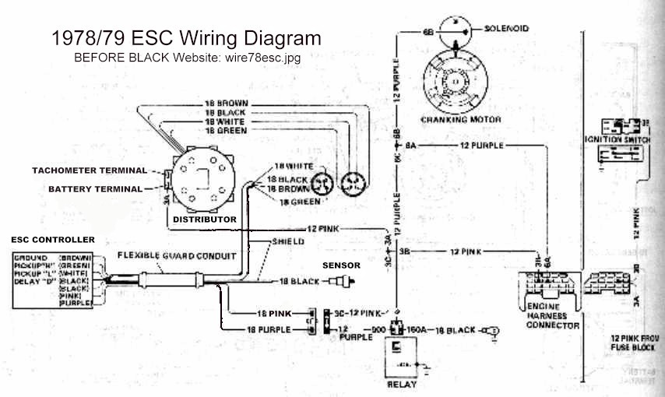
It is common to use the Turbo V6 on non-factory set ups. Many times if the engine was originally a CCC version, computer has been disabled or removed. The ESC will not function, because it requires the ECM. The non-CCC ESC can be adapted to these engines to retain the system's protection. The 1978/80 are stand alone (in other words, only need the ECM). The ESC controller, distributor, an early style knock sensor and a little rewiring are all that is required. Here is the '78/79 wiring diagram for the ESC. (1980 is similar, but the exact wiring is a little different):

