Splices and Repairs
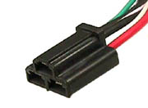 | Fan Delay Relay C1 Connector  Code:108001  Price: $15.00  Quantity in Basket: none
Top of Form | Bottom of Form
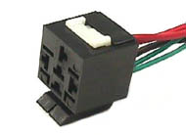 | Lo Speed Fan Relay Connector  Code:108002  Price: $15.00  Quantity in Basket: none
Top of Form | Bottom of Form
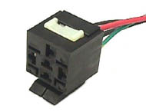 | Hi Speed Fan Relay Connector  Code:108003  Price: $15.00  Quantity in Basket: none
Top of Form | Bottom of Form
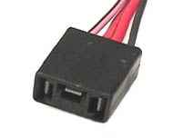 | Fan Delay Relay C2 Connector  Code:108004  Price: $15.00  Quantity in Basket: none
Top of Form | Bottom of Form
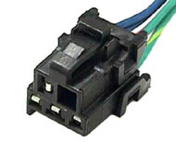 | A/C Relay Connector Splice  Code:108005  Price: $15.00  Quantity in Basket: none
Top of Form | Bottom of Form
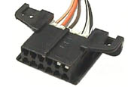 | ALDL Port Splice  Code:108006  Price: $20.00  Quantity in Basket: none
Top of Form | Bottom of Form
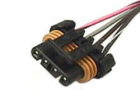 | EGR Solenoid Splice - 86/89  Code:108007  Price: $15.00  Quantity in Basket: none
Top of Form | Bottom of Form
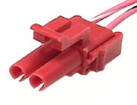 | Wastegate Solenoid Splice  Code:108009  Price: $15.00  Quantity in Basket: none
Top of Form | Bottom of Form
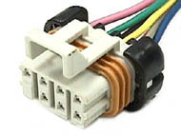 | Injector Haress Engine Side  Code:108010  Price: $22.00  Quantity in Basket: none
Top of Form | Bottom of Form
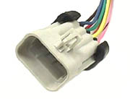 | Injector Harness Intake Side  Code:108011  Price: $22.00  Quantity in Basket: none
Top of Form | Bottom of Form
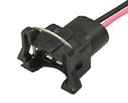 | Fuel Injector Splice  Code:108012  Price: $15.00  Quantity in Basket: none
Top of Form | Bottom of Form
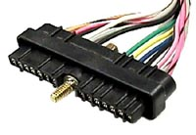 | CCCI Splice - 1986 / 1989  Code:108014  Price: $29.00  Quantity in Basket: none
Top of Form | Bottom of Form
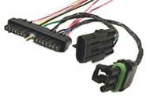 | CCCI Splice with Crank and  Code:108015  Price: $49.00  Quantity in Basket: none
Top of Form | Bottom of Form
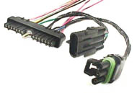 | CCCI Splice with Crank and Cam Plugs - Special  Code:108016  Price: $49.00  Quantity in Basket: none
Top of Form | Bottom of Form
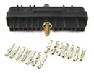 | CCCI Connector With  Code:108017  Price: $25.00  Quantity in Basket: none
Top of Form | Bottom of Form
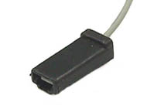 | Fuel Pump Test Tap Splice  Code:108018  Price: $15.00  Quantity in Basket: none
Top of Form | Bottom of Form
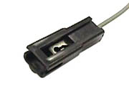 | Fuel Pump Test Tap Mating  Code:108019  Price: $15.00  Quantity in Basket: none
Top of Form | Bottom of Form
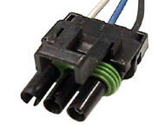 | Cam Sensor Splice  Code:108020  Price: $15.00  Quantity in Basket: none
Top of Form | Bottom of Form
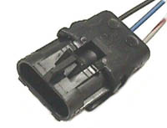 | Cam Sensor Splice  Code:108021  Price: $15.00  Quantity in Basket: none
Top of Form | Bottom of Form
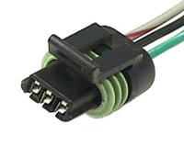 | Crank Sensor Splice Engine  Code:108022  Price: $18.00  Quantity in Basket: none
Top of Form | Bottom of Form
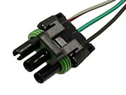 | Crank Sensor Splice  Code:108023  Price: $15.00  Quantity in Basket: none
Top of Form | Bottom of Form
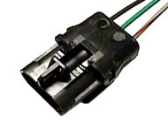 | Crank Sensor Splice  Code:108024  Price: $15.00  Quantity in Basket: none
Top of Form | Bottom of Form
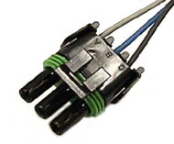 | TPS Connector Splice - 86/89  Code:108026  Price: $15.00  Quantity in Basket: none
Top of Form | Bottom of Form
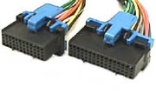 | ECM Splice Harness Side  Code:108027  Price: $56.00  Quantity in Basket: none
Top of Form | Bottom of Form
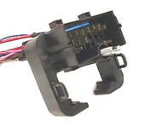 | C-100 Bulkhead Splice  Code:108028  Price: $32.00  Quantity in Basket: none
Top of Form | Bottom of Form
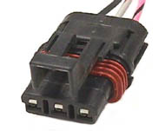 | Mass Airflow Splice Harness  Code:108029  Price: $15.00  Quantity in Basket: none
Top of Form | Bottom of Form
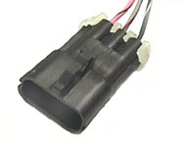 | Mass Airflow Mating Splice  Code:108030  Price: $15.00  Quantity in Basket: none
Top of Form | Bottom of Form
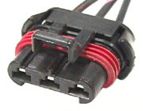 | Coolant Fan Splice  Code:108031  Price: $22.00  Quantity in Basket: none
Top of Form | Bottom of Form
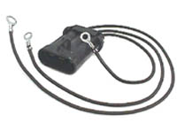 | Coolant Fan Harness - 86/87  Code:108032  Price: $29.00  Quantity in Basket: none
Top of Form | Bottom of Form
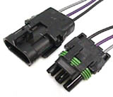 | Fuel Tank Connector Pair  Code:108033  Price: $25.00  Quantity in Basket: none
Top of Form | Bottom of Form
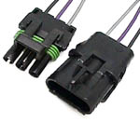 | Fuel Tank Connector Pair Splice  Code:108035  Price: $24.00  Quantity in Basket: none
Top of Form | Bottom of Form
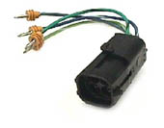 | IAC Relocator - 84/89  Code:108037  Price: $24.00  Quantity in Basket: none
Top of Form | Bottom of Form
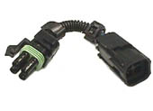 | IAC Extender - 84/89  Code:108038  Price: $24.00  Quantity in Basket: none
Top of Form | Bottom of Form
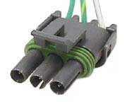 | A/C Pressure Line Splice  Code:108039  Price: $15.00  Quantity in Basket: none
Top of Form | Bottom of Form
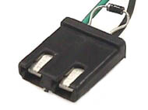 | A/C Compressor with Diode  Code:108040  Price: $20.00  Quantity in Basket: none
Top of Form | Bottom of Form
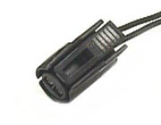 | A/C Compressor Switch Splice  Code:108041  Price: $15.00  Quantity in Basket: none
Top of Form | Bottom of Form
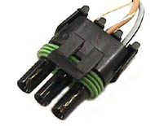 | Power Master 3 Cavity Splice  Code:108042  Price: $15.00  Quantity in Basket: none
Top of Form | Bottom of Form
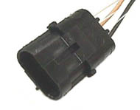 | Power Master 3 Cavity Mating Splice  Code:108043  Price: $15.00  Quantity in Basket: none
Top of Form | Bottom of Form
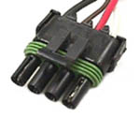 | Power Master 4 Cavity Splice  Code:108044  Price: $15.00  Quantity in Basket: none
Top of Form | Bottom of Form
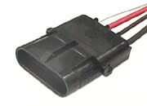 | Power Master 4 Cavity Mating  Code:108045  Price: $15.00  Quantity in Basket: none
Top of Form | Bottom of Form
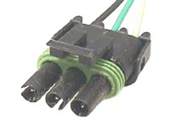 | MAP Sensor Splice - 84/89  Code:108046  Price: $15.00  Quantity in Basket: none
Top of Form | Bottom of Form
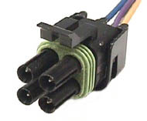 | TCC Harness Side Splice  Code:108047  Price: $15.00  Quantity in Basket: none
Top of Form | Bottom of Form
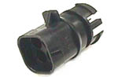 | TCC Connector Trans End  Code:108048  Price: $15.00  Quantity in Basket: none
Top of Form | Bottom of Form
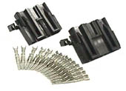 | C437 Mating Connector with Terminals  Code:108049  Price: $24.00  Quantity in Basket: none
Top of Form | Bottom of Form
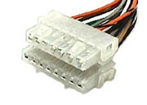 | C437 Mating Pair - 84/87  Code:108050  Price: $29.00  Quantity in Basket: none
Top of Form | Bottom of Form
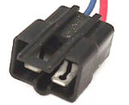 | Heater Feed - 84/87  Code:108051  Price: $15.00  Quantity in Basket: none
Top of Form | Bottom of Form
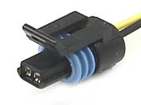 | Coolant Temp Sensor Splice - Connector  Code:108052  Price: $15.00  Quantity in Basket: none
Top of Form | Bottom of Form
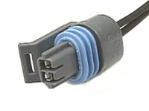 | Air Temp Sensor Splice  Code:108053  Price: $15.00  Quantity in Basket: none
Top of Form | Bottom of Form
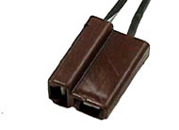 | Digital Dash Boost Switch  Code:108054  Price: $15.00  Quantity in Basket: none
Top of Form | Bottom of Form
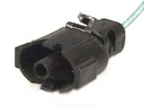 | Knock Sensor Splice - 84/89  Code:108055  Price: $15.00  Quantity in Basket: none
Top of Form | Bottom of Form
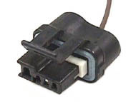 | Alternator Connector Splice  Code:108057  Price: $15.00  Quantity in Basket: none
Top of Form | Bottom of Form
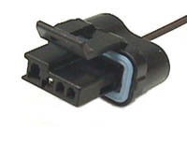 | Alternator Connector Splice  Code:108058  Price: $15.00  Quantity in Basket: none
Top of Form | Bottom of Form
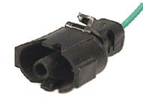 | HI Temp Switch Splice -84/89  Code:108059  Price: $15.00  Quantity in Basket: none
Top of Form | Bottom of Form
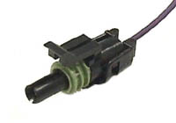 | 02 Sensor Harness  Code:108060  Price: $10.00  Quantity in Basket: none
Top of Form | Bottom of Form
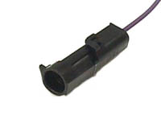 | 02 Sensor  Code:108061  Price: $10.00  Quantity in Basket: none
Top of Form | Bottom of Form
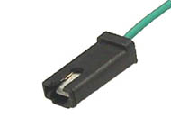 | Hot Engine Switch Splice  Code:108062  Price: $15.00  Quantity in Basket: none
Top of Form | Bottom of Form
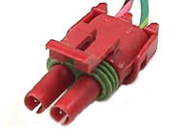 | Canister Purge Splice -84/89  Code:108063  Price: $15.00  Quantity in Basket: none
Top of Form | Bottom of Form
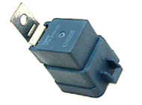 | Sealed Relay SPST blue 30AMP  Code:108064  Price: $15.00  Quantity in Basket: none
Top of Form | Bottom of Form
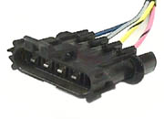 | ESC Module Splice - 84/89  Code:108065  Price: $15.00  Quantity in Basket: none
Top of Form | Bottom of Form
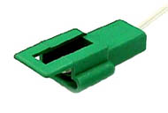 | Tach Tap Harness Side Splice  Code:108066  Price: $15.00  Quantity in Basket: none
Top of Form | Bottom of Form
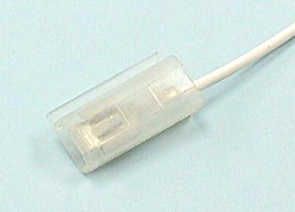 | Tach Tap Mating Splice  Code:108067  Price: $15.00  Quantity in Basket: none
Top of Form | Bottom of Form
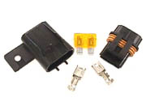 | Sealed Fuse Holder ATC  Code:108068  Price: $16.00  Quantity in Basket: none
Top of Form | Bottom of Form
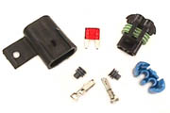 | Sealed Fuse Holder ATM  Code:108069  Price: $16.00  Quantity in Basket: none
Top of Form | Bottom of Form
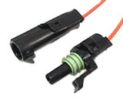 | ECM Memory Splice  Code:108070  Price: $19.00  Quantity in Basket: none
Top of Form | Bottom of Form
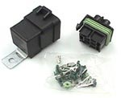 | Sealed Relay Kit 12 Gage  Code:108071  Price: $24.00  Quantity in Basket: none
Top of Form | Bottom of Form
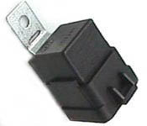 | Sealed Relay 30 AMP Black  Code:108072  Price: $15.00  Quantity in Basket: none
Top of Form | Bottom of Form
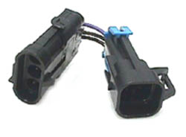 | 3 Wire Sensor to 4 Wire Kit Adapter  Code:108073  Price: $19.00  Quantity in Basket: none
Top of Form | Bottom of Form
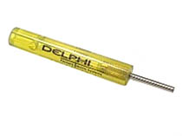 | Weather Pack Removal Tool  Code:108074  Price: $18.00  Quantity in Basket: none
Top of Form | Bottom of Form
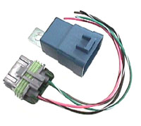 | Relay Upgrade Kit 84/87 GN  Code:108075  Price: $32.00  Quantity in Basket: none
Top of Form | Bottom of Form
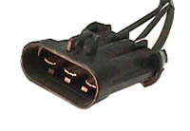 | Relay Upgrade Kit 84/87 GN  Code:108078  Price: $32.00  Quantity in Basket: none
Top of Form | Bottom of Form
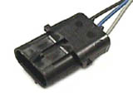 | TPS Special Mating  Code:108079  Price: $15.00  Quantity in Basket: none
Top of Form | Bottom of Form
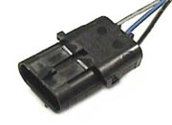 | TPS Special Mating  Code:108080  Price: $15.00  Quantity in Basket: none
Top of Form | Bottom of Form
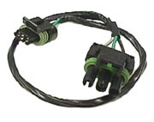 | 1987 Cransk sensor to 84/85  Code:108081  Price: $24.00  Quantity in Basket: none
Top of Form | Bottom of Form
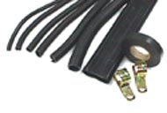 | Detail Kit - 86/87  Code:108082  Price: $39.95  Quantity in Basket: none
Top of Form | Bottom of Form
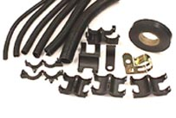 | Detail Kit - 84/85  Code:108083  Price: $39.95  Quantity in Basket: none
Top of Form | Bottom of Form
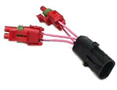 | Wastegate Solenoid Splitter 2 Way  Code:108084  Price: $29.00  Quantity in Basket: none
Top of Form | Bottom of Form
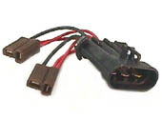 | SPAL Dual Fan Adapter -86/87  Code:108085  Price: $29.00  Quantity in Basket: none
Top of Form | Bottom of Form
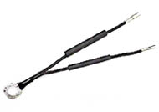 | Fuse Link Kit Standard  Code:108088  Price: $18.00  Quantity in Basket: none
Top of Form | Bottom of Form
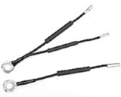 | Fuse Link Kit Std. - 86/87  Code:108089  Price: $20.00  Quantity in Basket: none
Top of Form | Bottom of Form
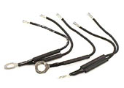 | Hi Performance Fuse Link Kit  Code:108091  Price: $24.00  Quantity in Basket: none
Top of Form | Bottom of Form
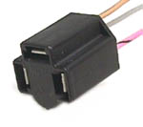 | Oil Pressure Sensor Splice  Code:108092  Price: $15.00  Quantity in Basket: none
Top of Form | Bottom of Form
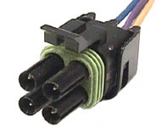 | IAC Splice - 84/89  Code:108093  Price: $15.00  Quantity in Basket: none
Top of Form | Bottom of Form
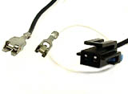 | Fuel Pump Tank Connector  Code:108094  Price: $18.00  Quantity in Basket: none
Top of Form | Bottom of Form
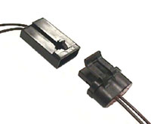 | Alternator Connectors Mating Pair w/wires  Code:108095  Price: $22.00  Quantity in Basket: none
Top of Form | Bottom of Form
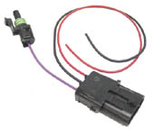 | AFS-74 to Grand National Wiring Adapter  Code:108096  Price: $18.00  Quantity in Basket: none
Top of Form | Bottom of Form
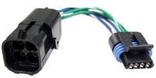 | IAC MP to F-WP Adapter  Code:108101  Price: $22.00  Quantity in Basket: none
Top of Form | Bottom of Form
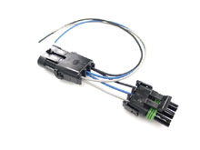 | TPS Breakout - 86/87 GN  Code:108105  Price: $18.00  Quantity in Basket: none
Top of Form | Bottom of Form
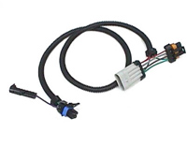 | Heated O2 Sensor Kit ONLY 86/87 Wiring Harness  Code:108110  Price: $32.00  Quantity in Basket: none
Top of Form | Bottom of Form

