To make your slappy original V8 Monza engine mount like new:

1. Take your mount and drill out the 3 clamps that holding the two metal plates together.
2. Take away the plates from the mounts. Leave the legs and the rubber.
3. Carve away ALL rubber from the mount. (piece with the legs)
4. When you have all the rubber gone, you have a U-shaped piece left (The two legs that mount to the chassis with a bend between the legs)
5. You can NOT mount the new engine mount on the bend on top, that piece must go away!
6. Look at the picture below, this is what you must do to make the new mount sit at the proper height on a flat surface:
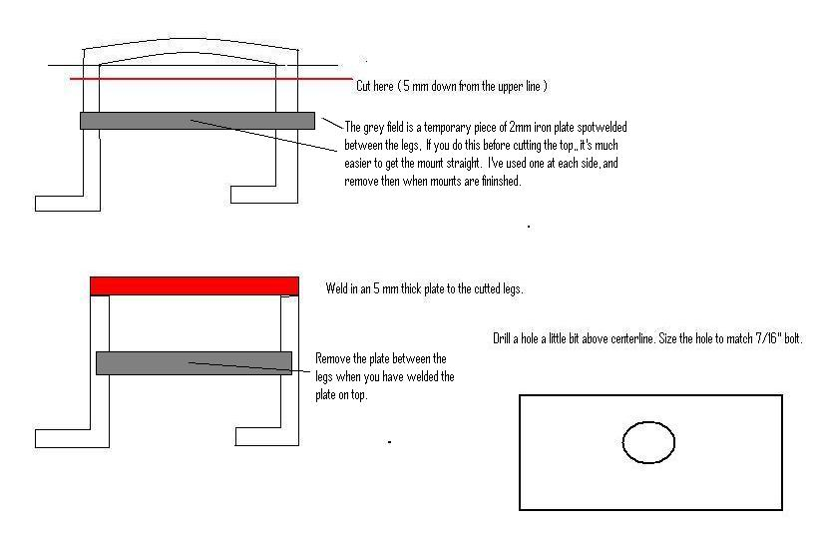
7. When you have done this, it shoud looks like the pictures below:
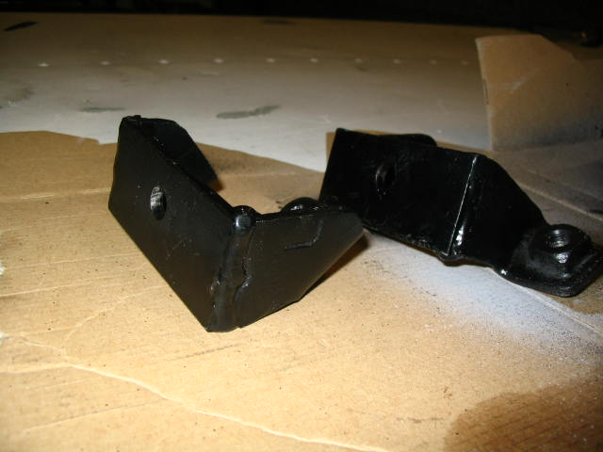
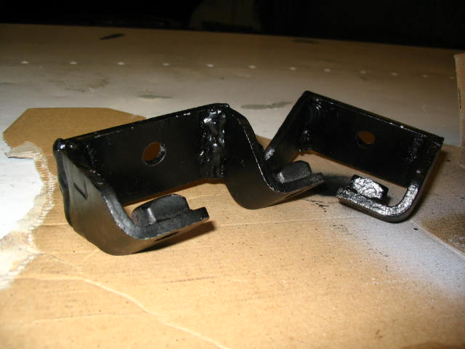
8. Buy 2 mounts (one for each side) for Chevy truck year mid 60's (I used Anchor 2282, orig. they came on -66 Chevy C10 283-327 ).
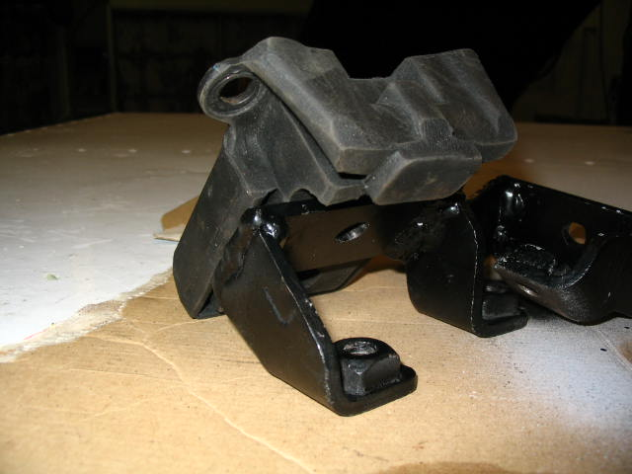
9. Bolt it together and into your car!
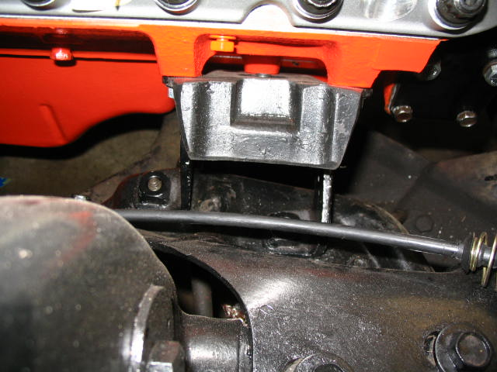
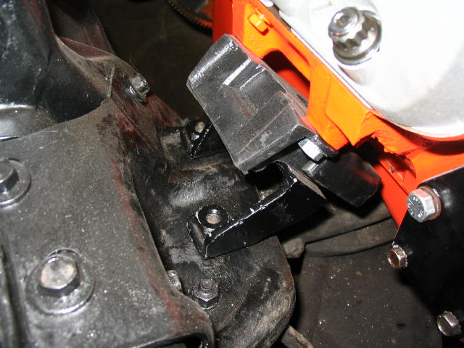
10. As you can see, perfect distance to the steering. When sat in the car for a while, it’s about 1/2 inch clearance.
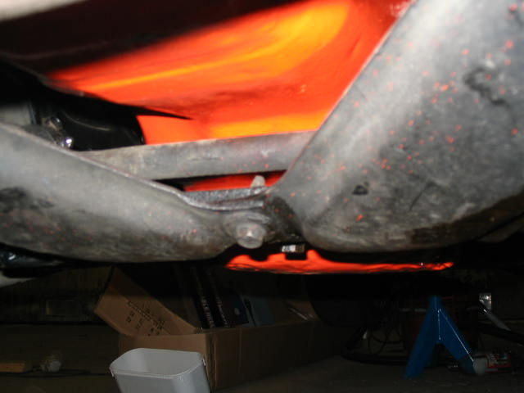

Any Q can mailed to: Thomas

